**Experiment No. 2.1**

**Student Name: Rishav Kumar UID: 22MCC20039**

**Branch: MCA - CCD Section/Group: MCD-1/ Grp A**

**Semester: III Date of Performance: 22th Sep 23**

**Subject Name: Business Analytics Subject Code: 22CAH-703**

1. **Aim/Overview of the practical:**

Installation of Oracle/SQL

**2. Code for practical:**

* Search download mySQL on Google and download MSI installer.
* After downloading, run installer.

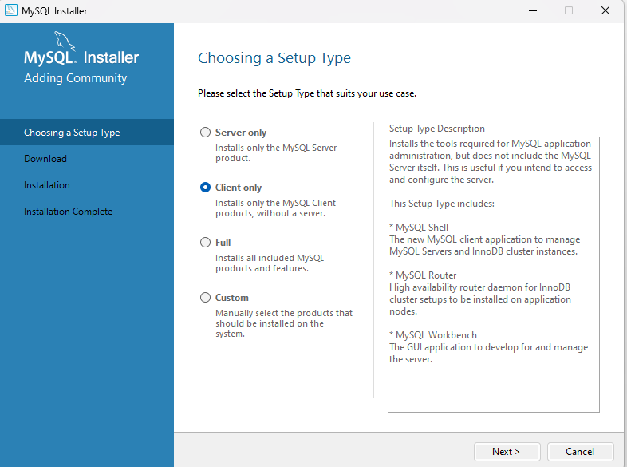

* Click on Client only.
* Select path and click on Next button.
* It will download products for installation.
* After downloading, it will install the products.

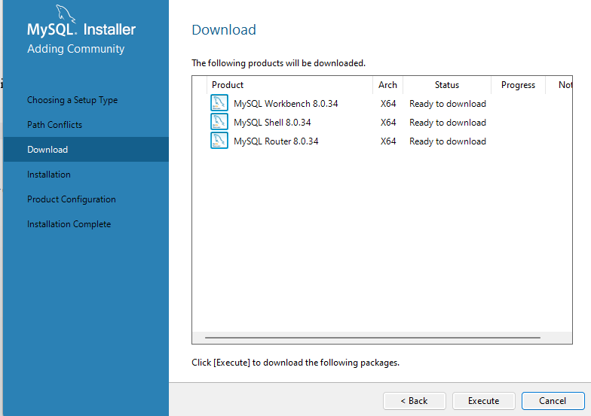

* Click on Finish after installation.

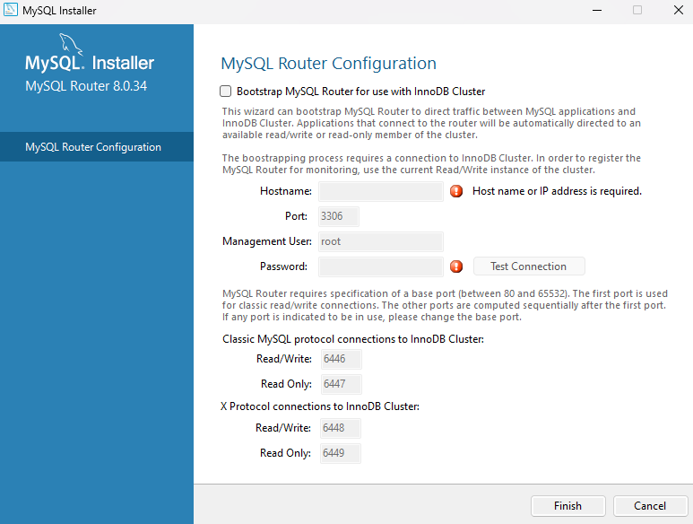

* My SQL will be installed.

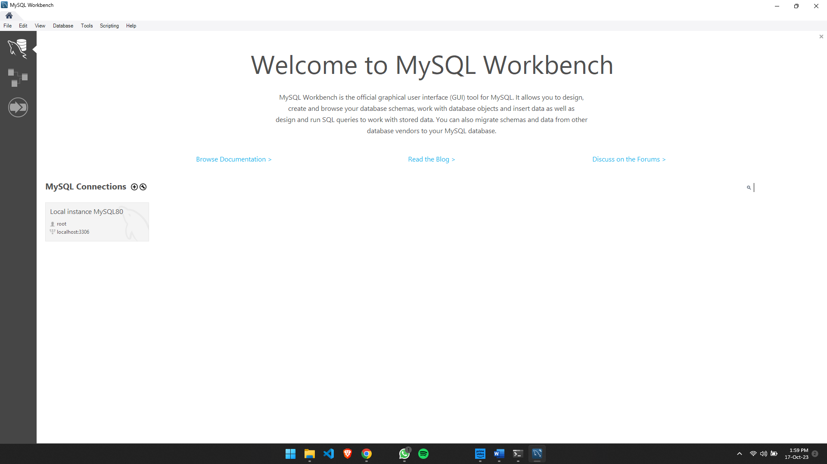

**************************************** **THE END** ***********************************************